# Question 3

|  |  |  |  |
| --- | --- | --- | --- |
| 1. Do charities which seek to help the public engage more with Twitter to reach the public? | - Table of public facing chars  - Possibly summary of income and other for public and non-public  - Summary of followed on Twitter | - | - Linear followed on Twitter with public facing and income control  - Inverse logit with following predicted public facing? |

## Univariate

|  |  |  |
| --- | --- | --- |
|  | **Helps the general public** | **Does not help general public** |
| n | 5528 | 5272 |
| % | 51.2 | 48.8 |

Does not help general public

|  |  |  |  |
| --- | --- | --- | --- |
|  | **Income 2018** | **Proportion of general public funding** | **Twitter followers** |
| **Count** | 4612 | 5747 | 1976 |
| **Mean** | 1407509 | 0.014 | 2735 |
| **Std** | 1687574 | 0.029 | 3358 |
| **Median** | 758100 | 0 | 1508 |
| **Min** | 0 | -0.046 | 0 |
| **Max** | 7400000 | 0.151 | 17324 |

Just charities which help general public

|  |  |  |  |
| --- | --- | --- | --- |
|  | **Income 2018** | **Proportion of general public funding** | **Twitter followers** |
| **Count** | 4846 | 5544 | 2218 |
| **Mean** | 1297389 | 0.018 | 3788 |
| **Std** | 1622773 | 0.034 | 4118 |
| **Median** | 664300 | 0 | 2134 |
| **Min** | 0 | -0.024 | 0 |
| **Max** | 7400000 | 0.151 | 17446 |

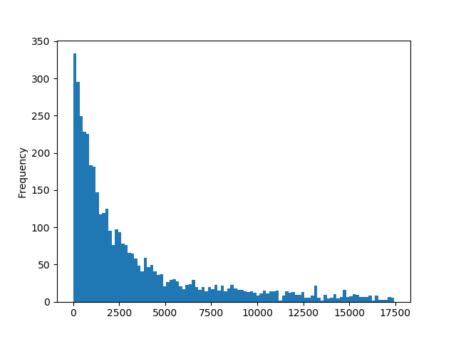

## Multivariate modelling

|  |  |  |  |
| --- | --- | --- | --- |
| **Dependent**: Twitter followers | **Coef.** | **Std error** | **P>|t|** |
| Helps general public | 1193 | 121 | 0.000 |
| Income 2018 | 0.000 | 0.000 | 0.000 |
| Constant | 1632 | 110 | 0.000 |

R-squared 0.064 Prob = 0.000 AIC =68230 BIC =68250

This first model is an OLS model which predicts income growth based on source of funding. Both of the effects in this model are insignificant, suggesting there is no evidence that source of funding affects subsequent income growth.

|  |  |  |  |
| --- | --- | --- | --- |
| **Dependent**: Helps general public | **Coef.** | **Std error** | **P>|t|** |
| Twitter followers | 0.000 | 0.000 | 0.000 |
| Income 2018 | -0.000 | 0.000 | 0.000 |
| Constant | 0.137 | 0.052 | 0.009 |

R-squared 0.027 AIC =4778 BIC =4797